Adult Chiropractic Intake Form

Confidential Patient Information
Dr. Michael Evans & Dr. Brittney Knowlton | Lake Country Family Chiropractic
112 Harmony Crossing Suite 1, Eatonton | 706-991-5348 |www.lakecountryfamilychiro.com

Name: SSN: Date:
Street Address: City: State: Zip:
Home Phone: Cell Phone: Work Phone:
Email: Date of Birth: Age
Height: Weight: Marital Status: Single Married Divorced Widowed
Emergency Contact: Phone Number: Relationship:
Whom may we thank for referring you?

Current Health Condition
Present complaint:

Location of complaint: Does the pain radiate?
When did this begin? Was there an accident or injury involved? Yes No
Have you had any past treatment for this complaint? Yes No
If yes – Please Explain

Is this condition: Getting worse Improving Intermittent Constant Unsure
Type of Pain: Achy Tight Tense Sharp Stiff Stabbing Throbbing Burning
Tingling Numb Dull
What makes the pain better? Worse?

Past Health History
Have you ever received chiropractic care? Yes No Doctor:
How long were you under care? Date of last visit:
Why did you stop?
List any surgeries or hospitalizations you have had:

List all medications you are currently taking and how often:

List any accidents/injuries/broken bones:

Family History: Cancer High Blood Pressure Diabetes Heart Attack Stroke Arthritis Other – Please explain:

Social History
Do you drink alcohol? Yes No
If yes, how much & how often?
Do you smoke? Yes No Former
If yes, how much, how often, & how long?

Do you think your appetite is: Heavy Moderate Light
Do you participate in a regular exercise program? Yes No
If yes, how often and what?

Are you currently employed? Yes No
If yes, what is your occupation?

Who is your current employer? How long have you been at this job?

Using the symbols given below, mark the area on your body where you feel the described pain sensations. Include all affected areas.
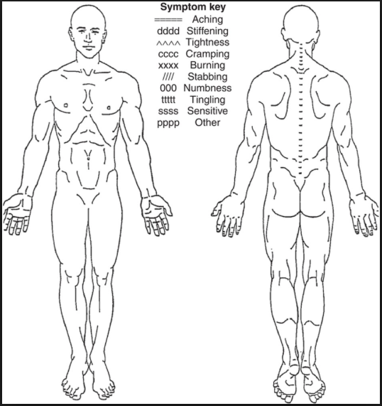

Review of Systems

The following items may relate to your current condition. Please place a “P” if you PRESENTLY have the problem and an “H” if you HAD the problem in the past. Leave the space blank if you NEVER had the problem.

GENERAL
_____Anemia
_____Allergies
_____Arthritis
_____Bleeding Problem
_____Cancer/Tumors
_____Diabetes
_____Epilepsy
_____Fainting or Seizures
_____Fibromyalgia
_____Gout
_____Hepatitis
_____High Cholesterol
_____Loss of Sleep
_____Multiple Sclerosis
_____Night Sweats
_____Osteoporosis
_____Tiredness
_____Thyroid Problems

CARDIOVASCULAR
_____Chest Pain
_____Heart Disease
_____High Blood Pressure
_____Irregular Heartbeat
_____Low Blood Pressure
_____Pacemaker
_____Poor Circulation
_____Stroke
_____Swelling of Ankles
_____Varicose Veins
_____Heart/Lung Defect

RESPIRATORY
_____Asthma
_____Difficulty Breathing
_____Chronic Cough
_____COPD
_____Emphysema
_____Pneumonia
_____Tuberculosis
_____Wheezing
Dr. Michael Evans & Dr. Brittney Knowlton | Lake Country Family Chiropractic
112 Harmony Crossing Suite 1, Eatonton | 706-991-5348 |www.lakecountryfamilychiro.com

GENITOURINARY
_____Difficulty Starting/Stopping Flow
_____Frequent Urination
_____Painful Urination

GASTROINTESTINAL
_____Poor Appetite
_____Black or Bloody Stools
_____Bloating/Gas
_____Colitis/IBS
_____Constipation
_____Diarrhea
_____Excessive Hunger or Thirst
_____Hemorrhoids
_____Hernia
_____Indigestion
_____Liver Disease
_____Loss of Bowel Control
_____Nausea
_____Reflux
_____Stomach Pain
_____Ulcers
_____Vomiting

GYNECOLOGICAL
_____Abnormal Periods
_____Dysmenorrhea
_____Endometriosis
_____Hot Flashes
_____Oral Contraceptive Use
_____PCOS
Date of last period__________
Last Mammogram __________
Last Pap Smear ________Abnormal? Yes No

NEUROLOGICAL/MENTAL
_____Anxiety
_____Anger/Aggression
_____Attention Deficit
_____Psychotic Episodes
_____Tremors
_____Mental Disorder

